King Tut (Tutankhamun)
(pronounced: Tutenkh - amen)
Egyptian Pharaoh of the 18th Dynasty (1341-1323 BCE)
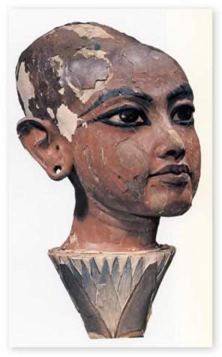 1. Tutankhamun on a Lotus (found in King Tut’s Tomb)
King Tut was the Egyptian Pharaoh of the 18th Dynasty of ancient Egypt. What is a Pharaoh? The title of Monarchs of ancient Egypt, similar to “Ruler” or “King”. What is the 18th Dynasty? It was the first Dynasty of the Ancient Egyptian New Kingdom period.
- King Tut was 9 years old when he became the 12th Pharaoh of the 18th Dynasty and accomplished little during his Reign (1332 - 1323 BCE). His advisors did restore traditional Egyptian religion, which his father had banned during his reign.
- King Tut only lived to be 19 years old and was largely forgotten until his tomb was found intact in 1922.
- This wooden life size head was found in his tomb and is covered in gesso (plaster) and painted. It represents traditional Egyptian religion, which he reinstated.
- It is a sculpture is a young King Tut, being “reborn” out of a Lotus flower, which is one of the theories Egyptians had about the origin of the Universe. This identifies him with the Sun God, who is reborn every morning also.

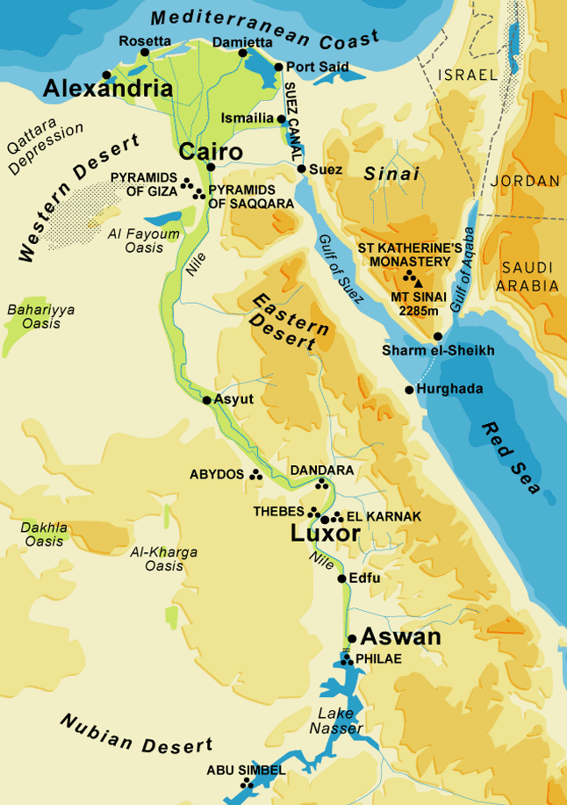 2. Map of Egypt
- Egypt is where King Tut reigned during the 18th Dynasty. It is known as the “land between the deserts” because it is virtually isolated by burning sands.
- Man began to settle in Egypt more than 10,000 years ago. Sustained by the Nile River, the land prospered, and in the Fourth Millennium before Christ, burst into splendor under the first of the pharaohs.
- What type of climate do you think Egypt has? Would you want to live in a desert?
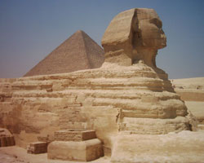 3. The Sphinx of Giza
- The Sphinx of Giza, which in English means: The Terrifying One, is a limestone statue of a reclining Sphinx. It is a mythical creature with the body of a lion and the head of a human.
- Facing directly from West to East, it stands on the Giza Plateau on the west bank of the Nile in Giza, Egypt.
- The Sphinx measures 238 feet long from paw to tail, 66.3 ft high from the base to the top of the head and 62.6 feet wide at its rear haunches.
- It is the oldest known monumental sculpture in Egypt and is commonly believed to have been built by ancient Egyptians of the Old Kingdom during the reign of the Pharaoh Khafre (c. 2558–2532 BC).

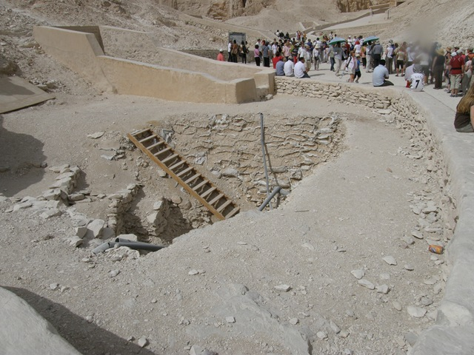4. Entrance to the Tomb
- King Tut’s tomb was discovered in 1922 by the archaeologist Howard Carter in the Valley of the Kings (a royal burial ground on the west bank of the ancient city of Thebes). The nearly intact tomb held a lot of objects that gave insight into that period of ancient Egyptian history.
- In November of 1922, Carter found the first of 12 steps of the entrance to the Tomb and on November 26, 1922 made a hole in the entrance of the antechamber to get in.
- Carter said there was so much gold, it glinted everywhere inside. There were so many artifacts he spent a decade cataloging and photographing all the teams findings.

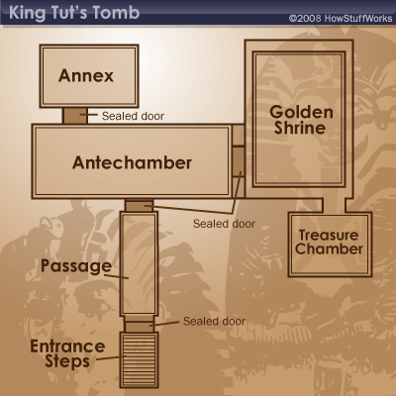5. Map of King Tut’s Tomb
- The tomb was comprised of 4 main rooms; the antechamber, the annex, the burial chamber and the treasury room. This tomb is one of two Pharaoh tombs found that wasn’t robbed of its treasures.
- There were roughly 5,000 objects within the tomb, the most famous being the gold death mask and coffin.
- Inside the final coffin was the mummy of the boy-king Tutankhamen, preserved for more than 3,000 years. Most of these treasures are now housed in the Cairo Museum.

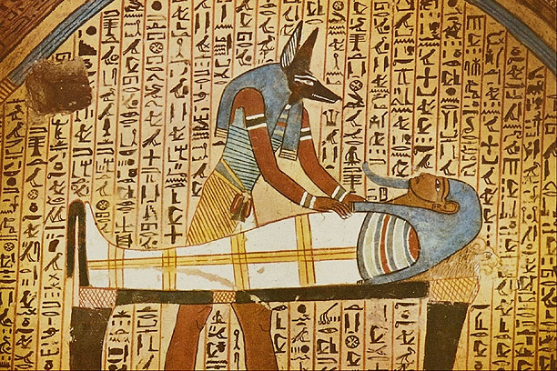 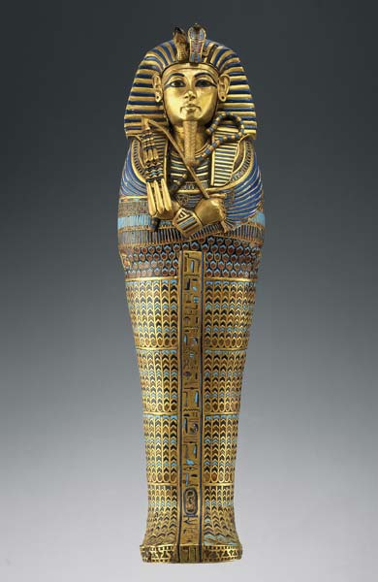 6. Tomb wall paintings; King Tut’s Coffin
- The burial chamber of King Tut’s tomb is the grandest. It was covered with yellow walls and paintings of King Tut in various representations.
- The walls were divided into four regions known as the northern, eastern, southern and western walls. Each wall has different depictions of King Tut ranging from death to his afterlife journey. In addition to pictures, hieroglyphics (a pictographic script used by Egyptians where symbols or pictures are used to represent items) was used to tell King Tut’s story.
- The gold coffin, known as the innermost coffin, was actually the third of 3 coffins King Tut was placed inside. The first two coffins were made of wood and covered in Gold and semiprecious stones, such as lapis and turquoise.
- The innermost coffin was made of solid gold and depicted King Tut as a God. The Gods were thought to have skin of gold, bones of silver, and hair of lapis - so the King is shown here in his divine form in the afterlife.
- He holds the crook and flail, symbols of the king’s right to rule.

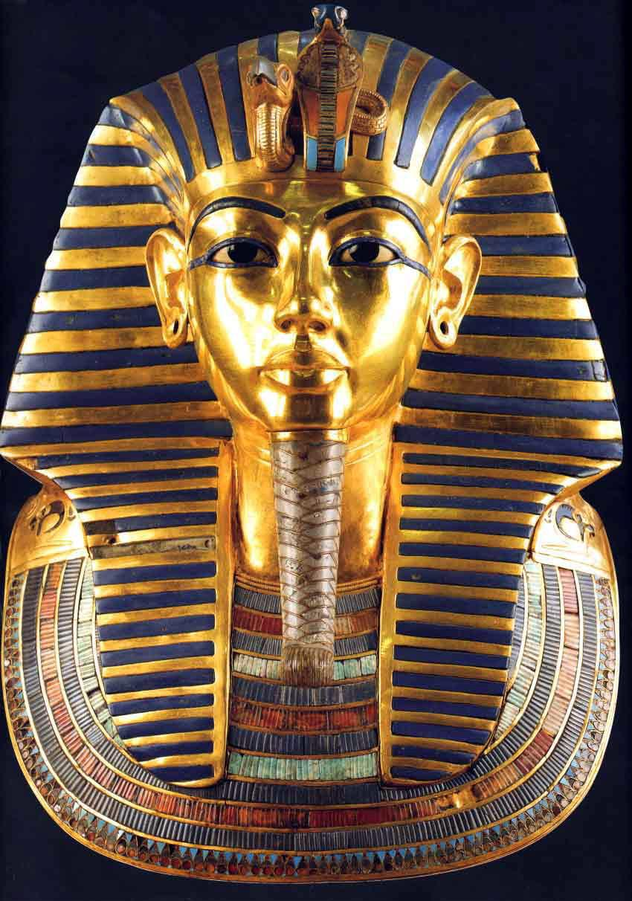7. Gold Funerary Mask
- The gold funerary mask is known as the death mask of King Tut. It is made of solid gold and weighs 24 pounds.
- King Tut’s mummy, which was wrapped in linen strips, wore the mask of his deceased head and shoulders. It is meant to replicate the boy King’s portrait with similar ears, lips and nose.
- The headdress has stripes which are made of blue glass. The same material is in the false beard.
- There is a vulture’s head on the brow, which symbolizes King Tut’s sovereignty (power or authority) over upper Egypt.
- Finally, there is the cobra next to the vulture, which symbolizes King Tut’s sovereignty over lower Egypt.

And now we will make our own Gold Mask on sand paper!

