Science Notes:

Everything is made of **matter** and matter is made up of **building blocks called atoms**.

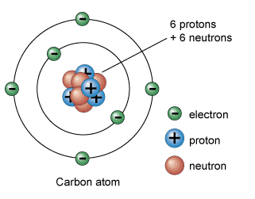

Atoms are in turn made of 3 basic parts

Protons (positive charge)

Electrons (negative charge)

Neutrons (neutral)

The PERIODIC TABLE consists of an organized arrangement of all the known atoms. It tells a lot of information about each atom but just remember that the **ATOMIC NUMBER is the number of protons in an atom.**

**Electrons are about 2000 times smaller than Protons.**

**The atomic mass is the protons electrons and neutrons added together, but since electrons are so small the atomic mass is basically the protons plus the neutrons.**

**Isotopes:** A version of an element with the same number of protons but a different number of neutrons. This can gives an atom different properties

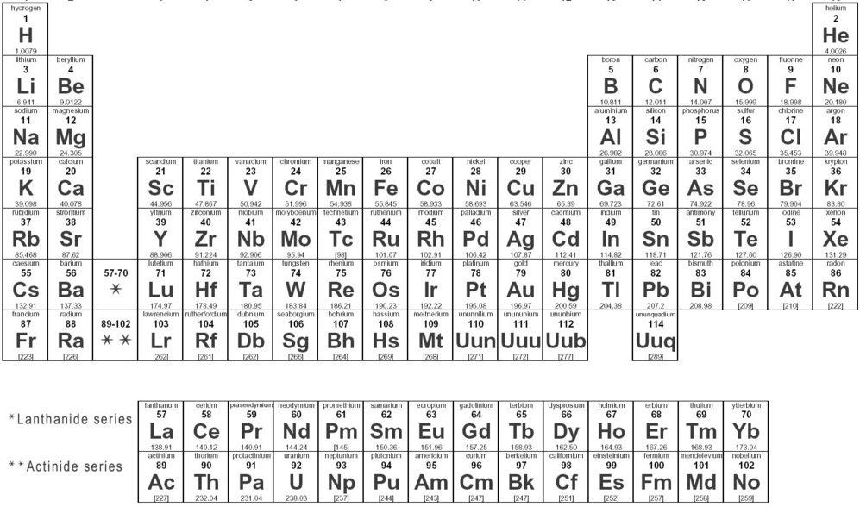

Compared to the size of the protons, neutrons and electrons the distance between the nucleus and the closest electron is huge! If you were to expand the nucleus to the size of the tip of a pin, the closest electron would be over 100 meters away!

**Opposites Attract and Likes Repel.** Electrons push away from other electrons and are attracted to protons.

Electricity is the flow of electrons through a conductor. (a conductor allows electrons to flow through; for example metal)

As energy is added to matter, the electrons move farther away from the **nucleus or center of the atom.** This fact is why things expand when heated.

Most substances expand when heated and contract or shrink when cooled down.

**STATES OF MATTER**

There are 4 states of matter**, Solid, Liquid, Gas and Plasma.**  Only the first 3 are found naturally on Earth. As energy is added to matter, it changes states. Solid is the lowest energy state and the electrons are closer to the nucleus. As energy is added the electrons move farther away and a substance can go through a PHASE CHANGE. Ice is cold and solid, heat it up (add energy) and it turns to a liquid. If you add more energy and it gets hotter it will boil and turn into a gas (steam). Solid-Liquid-Gas lowest to highest energy states. This is why most things expand as they change states HOWEVER WATER IS AN EXCEPTION: Water expands when it freezes and this is why water lines break when they freeze in the winter. Ice cubes float because they are less dense as a solid because water expands when it freezes.

**DRY ICE**

**CO2 is heavier than the air we breathe.** We proved this with a balance scale that we built in the room. We hung a meter stick from a wire and placed a plastic bag at each end. We poured the gas from dry ice into one bag and it sank down proving CO2 is heavier than air.

**Imploding Cans**

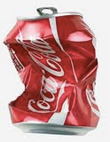In this demonstration we heated up aluminum cans to expand the air inside and then quickly cooled them down to make the interior gas contract or get smaller. The outside air pressure (14.7PSI) was greater than the inside pressure so the can was crushed.

**Bell Jar Vacuum Experiments**



A bell jar is a device to show the effects of a vacuum on an object. An item is placed under the sealed jar and the air in the jar is removed. As the pressure inside the jar DECREASES the remaining gases expand. Balloons get bigger, marshmallows expand, bubbles grow, sealed containers pop open, even water boils in a low pressure environment.

**Increase Pressure** around a balloon and the **balloon contracts**.

**Decrease pressure** around a balloon and **the balloon expands.**

**Increase pressure INSIDE a balloon and the balloon expands.**

**Decrease pressure inside a balloon and the balloon contracts.**

**Pressures move FROM HIGH toward low. This would include gases, weather systems, water pressures, even concentrations of chemicals like salt water. A high concentration moves toward a low concentration.**

**ELECTRICITY**

Electricity is the flow of electrons. When electrons move it is called electricity.

A **CONDUCTOR** allows electrons to flow through it… like a wire or any metal.

An **INSULATOR** resists the flow of electrons or doesn’t let electricity flow through it easily.

**VOLTAGE** is the pressure of electricity. A 1.5 volt battery has much less pressure than a 12 volt car battery. You may think of it like water pressure or how much push there is like when you put your finger over a garden hose the water pressure tries to push your finger off with the water pressure. Voltage is pressure or electrical potential.

**Static Electricity**

Sometimes, when two different objects (insulators) are rubbed against each other (or even just touch) it is possible to strip electrons off of one and stick them to the other object. The object with extra electrons has a **Negative Charge** and the object missing electrons has a **positive** **charge**. Since we know that **opposites attract** and **likes repel** this gives us the opportunity to have some fun!

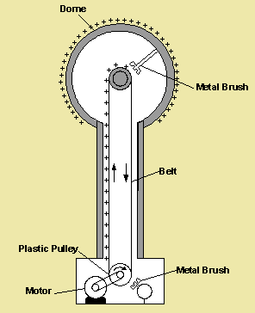A Van DeGraaff Generator can produce a great static charge it looks like this:



In class we did a few demonstrations where we place little pieces of tissue paper on the generator and turned it on. The pieces flew away. We then blew some soap bubbles at the generator and they were attracted and then repelled away. Do a little research to learn more about the Van DeGraaff generator.

When we had kids stand on their chairs, which were insulated from the floor, and hold hands, and had one of them touching the Van De Graaff generator, we found that an electric charge built up on every student. We could tell because the hair stood up on all the participants.

We did an Aluminum Pie Plate experiment where we place pie plates on top of the VDG generator and the plates flew off one at a time.